Your Vehicle: 2014 Cadillac ATS Sedan RWD L4-2.0L Turbo
Vehicle » Transmission and Drivetrain » Drive Axles, Bearings and Joints » Axle Shaft Assembly » Service and Repair » Rear Wheel Drive Shaft Replacement

Rear Wheel Drive Shaft Replacement

Rear Wheel Drive Shaft Replacement
Special Tools
J 45859 - Hub Puller
For the equivalent regional tools, refer to Special Tools See: Tools and Equipment.
Removal Procedure
- Raise and support the vehicle. Refer to Lifting and Jacking the Vehicle See: Maintenance\Vehicle Lifting\Service and Repair.
- Remove the tire and wheel assembly. Refer to Tire and Wheel Removal and Installation
- See: Maintenance\Wheels and Tires\Service and Repair.
- Remove the exhaust system for RPO LFX. Refer to Exhaust System Replacement (LFX) For RPO LCV and LTG refer to Exhaust
- Muffler Replacement (LCV) See: Engine, Cooling and Exhaust\Exhaust System\Muffler\Service and RepairExhaust Muffler
- Replacement (LTG) See: Engine, Cooling and Exhaust\Exhaust System\Muffler\Service and Repair.
- Remove the upper control arm bolt at the knuckle. Refer to Upper Control Arm Replacement
- See: Steering and Suspension\Suspension\Control Arm\Service and Repair\Rear Suspension\Upper Control Arm Replacement.
- Remove the trailing arm bolt at the knuckle. Refer to Trailing Arm Replacement (Upper)
- See: Steering and Suspension\Suspension\Trailing Arm\Service and Repair\Trailing Arm Replacement (Upper)Trailing Arm
- Replacement (Lower) See: Steering and Suspension\Suspension\Trailing Arm\Service and Repair\Trailing Arm Replacement (Lower).
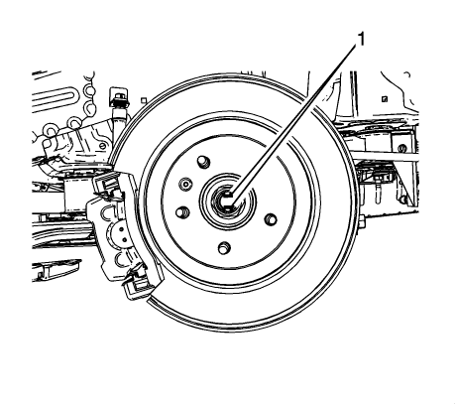
Caution: Make sure that the wheel drive shaft nut is fully un-staked to avoid damage to the wheel drive shaft threads during the removal of
the wheel drive shaft nut. Failure to follow these instructions could result in wheel, nut, and/or stud damage.
- Using a suitable punch and a hammer, unstake the drive shaft nut collar from the drive shaft slots (1).
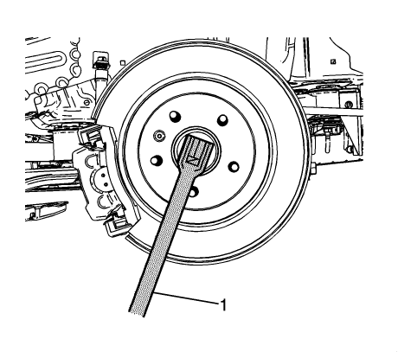
Note: DO NOT use air tools to remove the wheel drive shaft nut. Use hand tools ONLY.
- With the aid of an assistant holding the brake pedal down, use a breaker bar (1) and the proper size socket to loosen the wheel drive
- shaft nut.
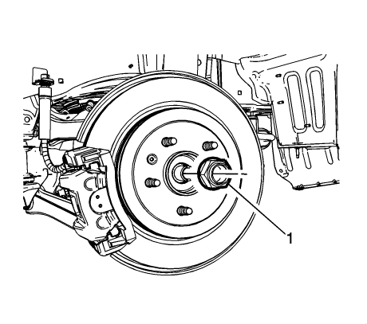
Note: DO NOT reuse wheel drive shaft nut. Discard and replace with NEW only.
- Remove and discard the wheel drive shaft retaining nut (1).
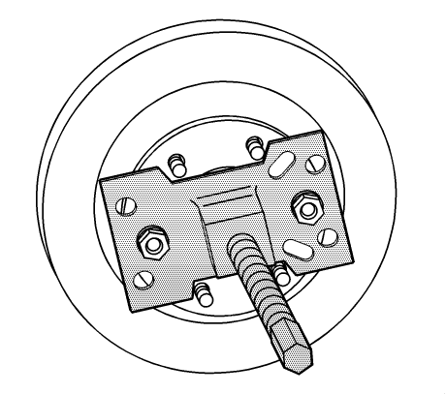

- Using the J 45859 - puller, separate the wheel drive shaft from the wheel bearing/hub assembly.
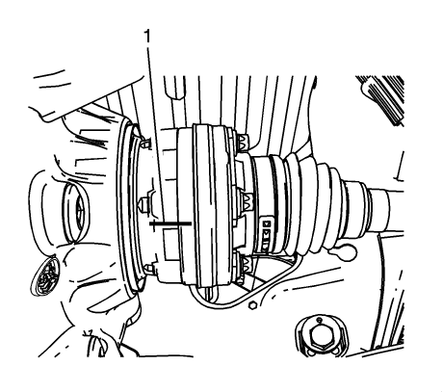

- Mark the relationship (1) of the wheel drive shaft to the output shaft flange.
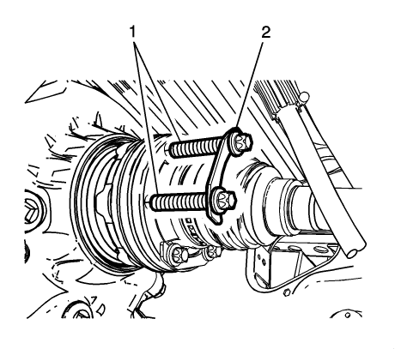
Note: The bolts may be reused but the washers are a one time use item and must be discarded each time the bolts are removed.
- Remove the wheel drive shaft mounting bolts (1) and the washers (2) from the differential drive flange. Discard the washers (2).
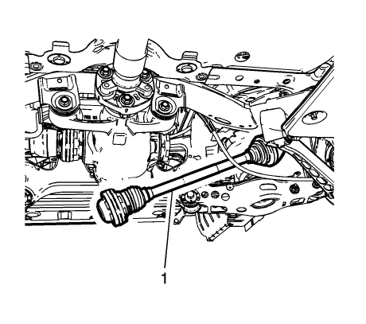
Note: Reposition the knuckle to allow the inner joint to pass the rear differential flange. It may be necessary to use a flat bladed tool to
separate the wheel drive shaft from the differential flange.
- Remove the wheel drive shaft (1) from the vehicle.
Installation Procedure

- Install the wheel drive shaft (1) in the vehicle and through the wheel bearing/hub assembly.
Note: DO NOT reuse wheel drive shaft nut. Use a NEW nut only.
- Hand start the NEW wheel drive shaft retaining nut (1).
Note: If reusing the wheel drive shaft bolts, the threads must be clean and free of debris prior to the application of the threadlocker to ensure
the proper adhesion and retention.
- Thoroughly clean the threads using denatured alcohol or equivalent and allow to dry.
Note: Ensure that there are no gaps in the threadlocker along the length of the filled area of the bolt. Allow the threadlocker to cure approximately
10 minutes before installation of the bolts.
- Apply threadlocker to the wheel drive shaft bolts. Refer to Adhesives, Fluids, Lubricants, and Sealers See: Specifications\Fluid Types.

- Align the reference mark (1) on the wheel drive shaft and the output shaft flange.
Note: DO NOT reuse wheel drive shaft bolt washers. Use a NEW washers only.
- Install NEW washers (2) and the wheel drive shaft bolts (1) and hand tighten.
Caution: Refer to Fastener Caution See: Service Precautions\Fastener Caution.
- Tighten the wheel drive shaft bolts to 58 Nm (43 lb ft).
Note: Tighten the NEW wheel drive shaft nut slowly to draw the wheel drive shaft into the hub assembly prior to tightening to specifications.
- With the aid of an assistant holding the brake pedal down, tighten the wheel drive shaft nut to 250 Nm (184 lb ft) .
Note: The wheel drive shaft nut collar should be fractured in the center of each slot of the wheel drive shaft.
- Using a hammer and a suitable punch, stake the wheel drive shaft nut collar into the drive shaft slots (1).
- Install the trailing arm bolt at the knuckle. Refer to Trailing Arm Replacement (Upper)
- See: Steering and Suspension\Suspension\Trailing Arm\Service and Repair\Trailing Arm Replacement (Upper)
- Trailing Arm Replacement (Lower)
- See: Steering and Suspension\Suspension\Trailing Arm\Service and Repair\Trailing Arm Replacement (Lower).
- Install the upper control arm bolt at the knuckle. Refer to Upper Control Arm Replacement
- See: Steering and Suspension\Suspension\Control Arm\Service and Repair\Rear Suspension\Upper Control Arm Replacement.
- Install the exhaust system for RPO LFX. Refer to Exhaust System Replacement (LFX) For RPO LCV and LTG refer to Exhaust Muffler
- Replacement (LCV) See: Engine, Cooling and Exhaust\Exhaust System\Muffler\Service and RepairExhaust Muffler Replacement (LTG)
- See: Engine, Cooling and Exhaust\Exhaust System\Muffler\Service and Repair.
- Install the tire and wheel assembly. Refer to Tire and Wheel Removal and Installation
- See: Maintenance\Wheels and Tires\Service and Repair.
- Remove the support and lower the vehicle.

